Asynchronous Js

Call stack is order of executing the function

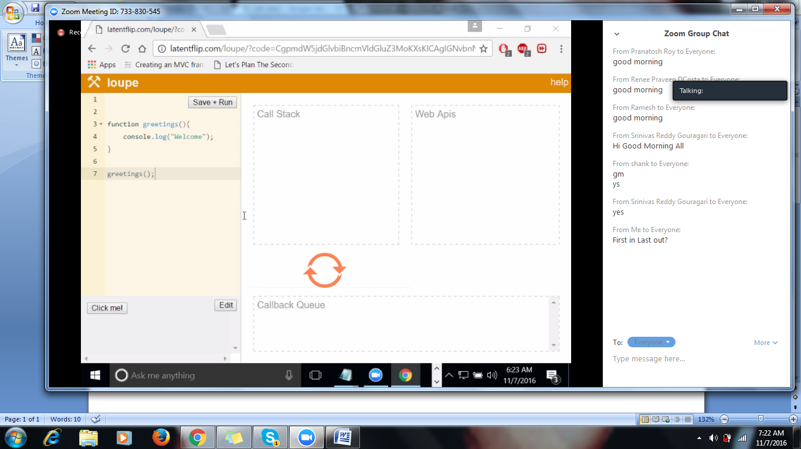

We need to wait until function completes until other fn executes,so will go to asynchronous call:

Asynchrnous prg

Set timeout is browssrs functn

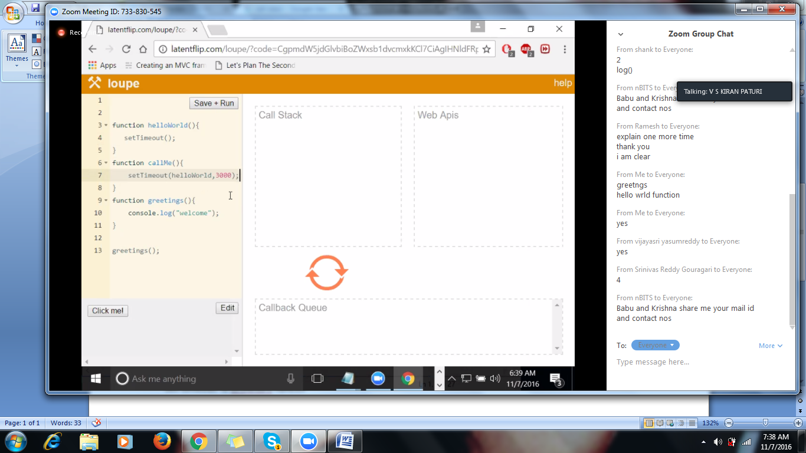

3 secs is atrigger to disply msg hellwrld

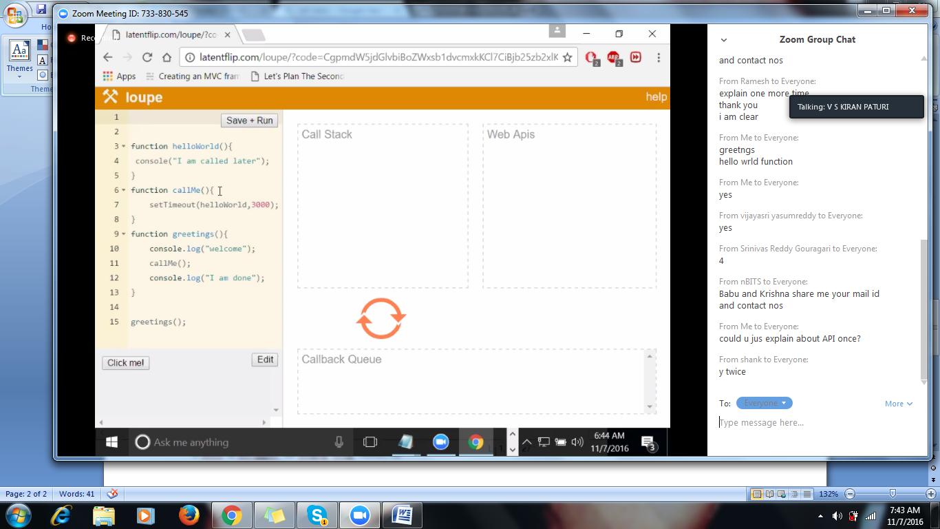

Intervw Qsns

-------------------

What is set timeout?

What is time interval?

What is a call back function?